**PyTorch Transfer Learning**

Beim Transfer Learning können wir die Modelle (auch Gewichte genannt), die ein anderes Modell für ein anderes Problem gelernt hat, für unser eigenes Problem verwenden.

For example, we take the patterns a computer vision model has learned from datasets such as ImageNet (millions of images of different objects) and use them to power FoodVision Mini model.

Or we take the patterns from a language model (a model that's been through large amounts of text to learn a representation of language) and use them as the basis of a model to classify different text samples.

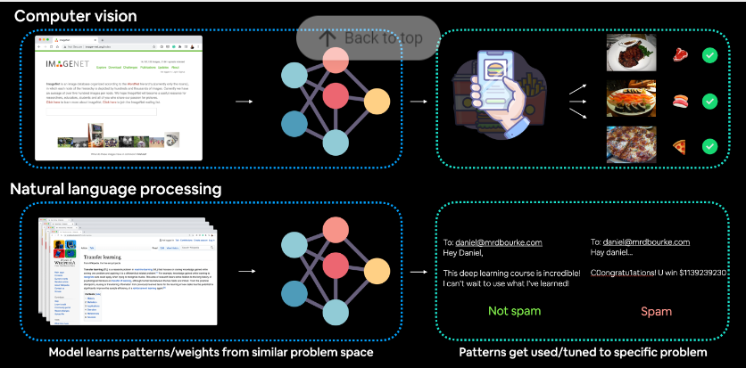

Where to find pretrained models?

PyTorch domain libraries: (torchvision, torchtext) come with pretrained models

HuggingFace Hub : pretrained models on many different domains (vision, text, audio and more)

timm (PyTorch Image Models) library: Almost all of the latest and greatest computer vision models in PyTorch

Paperswithcode:A collection of the latest state-of-the-art machine learning papers with code implementations attached.

Getting a pretrained model

VGG, EfficientNet, VisionTransformer, ConvNeXt